Practical 2
Definition : Handle missing Data (Drop, fill), convert column types in a given dataset using Pandas
Outcomes / Learning : Efficiently handling missing data and converting types are foundational steps in the data cleaning process, ensuring Data integrity and enabling proper Analysis.
Required Tool : The Experiment was performed using a Python Environment using Pandas Library, a Standard tool for Data Analysis.

Working : The Code first handles missing data by either dropping rows with .dropna(), or filling them with a specific value like the mean of the ‘age’ column using .fillna(),. It then converts the Data Types of the ‘thalach’, and ‘target’ columns to integer (int) and category, Respectively, to prepare The Data for further analysis.

Step 1 : The Initial Step involves Importing The Pandas, and Then The file is Then loaded into a Pandas Data Frame.
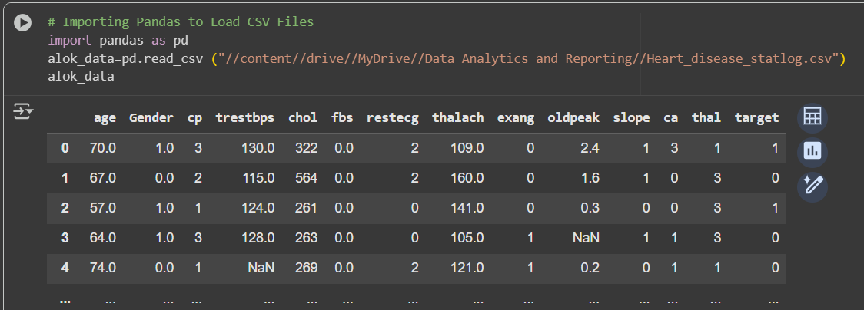
Step 2 : The Data frame Structure is cleaned by dropping the Unfilled Rows/Columns using .dropna() Function. 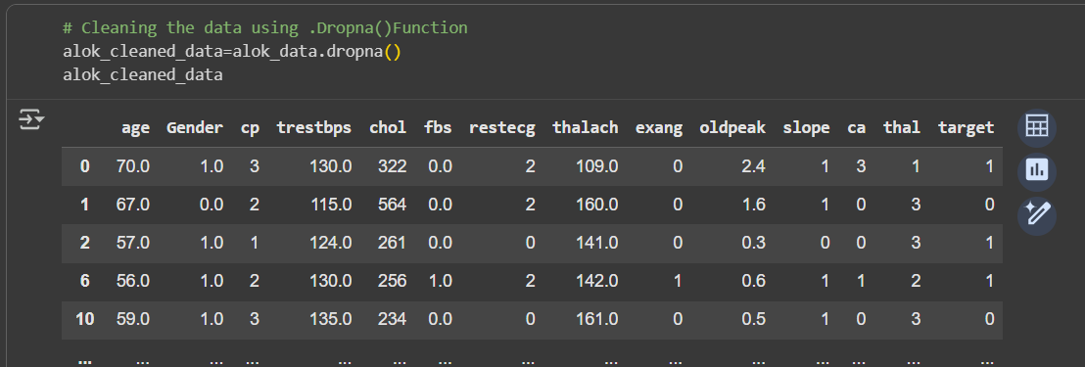

Step 3 : At places where the Mean value to be filled would be appropriate , will be filled using .fillna() function.
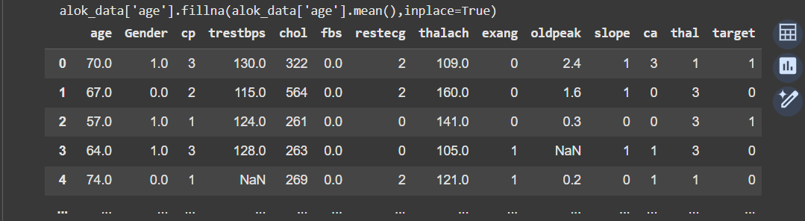

Step 4 : At places where the Negligible value to be filled would be appropriate, will be filled using .fillna() function.
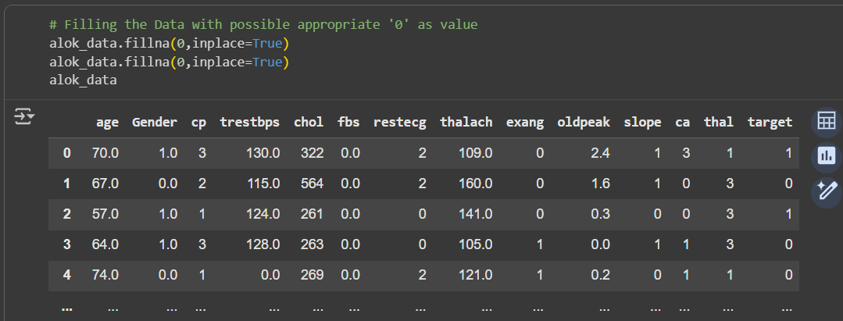
Step 5 : The desired Column types are Transformed or Changed into the desired Data types using The .astype() Function.
